TEAM?OARS

Web Site Design

Version 1.0

Signature Block

COSC 4351 | Name Signature | Date
SE Team Leader
SQA
This document includes the hand drowned or tool drowned of your TEAM?OXXS web site design.

You are to deliver AT LEAST ONE page at this time that contains the Master Page and the Home page.
- Content Outline for Master Page
- Wireframe for Master Page

Also, About Us, Contact Us, and Testimonials pages can be added at this time (all the pages will use the Master Page template).

Please add actual screenshot of your TEAM?OXXS web site on the following wireframe pages… Remember, your project is called TEAM?OXXS and it has to appear on each web page.

BACKGROUND: Site Structure
"Redesigning a website is like remodeling a kitchen - you must figure out what features and capabilities you need and how you will use them before you design your layout, place appliances and plugs, and select tiles, curtains and countertops." -- Web Redesign 2.0
Good web design requires a solid site architecture based on the site's goals and target audience established in the project brief. The deliverables from this phase are:
- Content Outline
- Site Diagram
- Page Description Diagrams
- Wireframes
These four deliverables are dependent on each other and need to be completed sequentially.

Content Outline
Working closely with your clients, create a list of all existing content. Brainstorm content that needs to be created for the site. Review the list of content, trimming anything that does not match the goals or audience needs as stated in the project brief. Take time to think about the future and how the site content might need to grow. Make sure you leave room for growth. Next group your content into categories. As you categorize your content, considering getting user feedback through a card sort. Once your categories are established, create an outline of your content and review it with your clients for accuracy.

Site Diagram
Take your final content outline and create a sitemap or site diagram. A site diagram is just a visual representation of your content outline and site structure. You can use Excel, Visio or Omnigraffle to create your site diagram. Refer to the The Lazy IA's Guide to Making Sitemaps article at Boxes and Arrows for a step-by-step example.
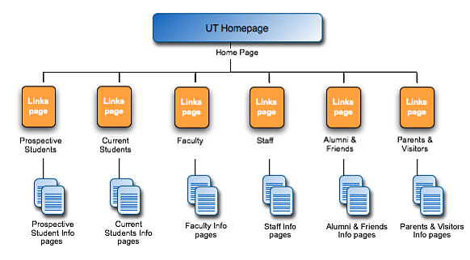

Page Description Diagrams
Many Information Architects are now recommending the use of Page Description Diagrams (PDD) as a step before wireframes or even as a replacement to wireframes. The focus of a PDD is two-fold:
- What content belongs on this page
- What is the priority of each chunk of content
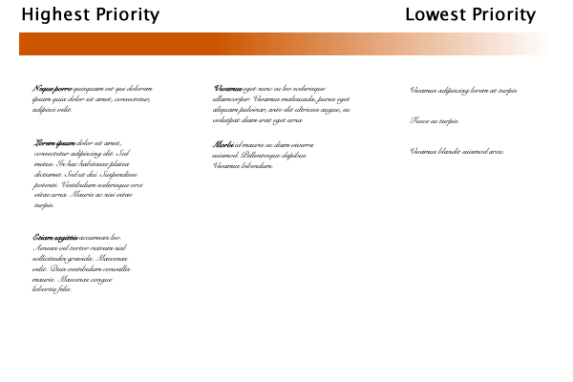
A common layout for the PDD is to use the horizontal access for priority. For example, a PDD for any give page might have three columns. The first column would list the high priority content. The second column would list the medium priority content. The third column would list the lowest priority content.
The advantages of the PDD over the wireframe include:
- clarifies all content for a given page
- clarifies the priority of each chunk of content
- completely removes visual design (color, font, placement) from this stage of the conversation.
Further reading on Page Description Diagrams:
- Where the Wireframes Are: Special Deliverable #3
- Information Architecture Deliverables: Page Description Diagrams

Wireframes
A wireframe is a non-graphical layout of a web page. It is a simple drawing of the chunks of information and functionality for each page in your site. You will want to create a wireframe for the home page, each unique second level page and any other significantly different page on the site.
Wireframes include the containers for all the major elements of the page. Elements include navigation, images, content, functional elements (like search) and footer.
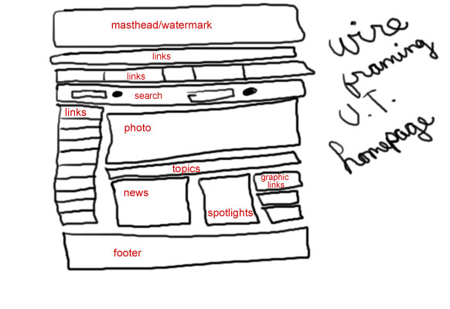

Document Control

Change History
(PLEASE REMOVE THIS BEFORE COMMITTING TO SVN!
NOTE: Team Leaders should place the TMs and SQA Name, Due Dates, Description BEFORE this document is released in SVN to TMs, DBAs, SQA!)

Table 1: TLs entries (assigned work and due dates) before releasing to the team
Revision | Name | Due Date | Description
1.A | TM & Name | XX/XX/XXXX | Complete XXX
1.B | TM & Name | XX/XX/XXXX | Complete YYY
1.C | DBA & Name | XX/XX/XXXX | Complete ZZZ
1.X | SQA & Name | XX/XX/XXXX | Review Document
1.Y | SQA & Name | XX/XX/XXXX | Review Document

Table 2: Entries when work completed (SVN Commit Comment matches Description)
Revision | Name | Completed Date | Description
1.A | TM & Name | XX/XX/XXXX | I completed XXX
1.B | TM & Name | XX/XX/XXXX | I completed YYY
1.C | DBA & Name | XX/XX/XXXX | I completed ZZZ
1.X | SQA & Name | XX/XX/XXXX | I reviewed Document
1.Y | SQA & Name | XX/XX/XXXX | I reviewed Document

(PLEASE REMOVE THIS BEFORE COMMITTING TO SVN!
NOTE: At the time of RED TEAMS DELIVERABLES, the Team Leaders should change the version on the COVER PAGE to 2.0 BEFORE COMMITTING back to SVN!!! Thus the last entry in CHANGE HISTORY should be the TLs)

Table 3: TL entry for RED DELIVERABLES (SVN Commit Comment matches Description)
Revision | Name | Due Date | Description
2.0 | TL & Name | XX/XX/XXXX | I changed Version to 2.0

Document Storage
This file is stored in SVN at https://svn.cs.u.edu/svn/cosc4351/team?/TEAM PROJECT DELIVERABLES/Web Site Design.doc.
(PLEASE REMOVE THIS BEFORE COMMITTING TO SVN!
NOTE: Team Leaders should change ONLY the ? with their team number!!!
DO NOT CHANGE the name of the document!!!! It will stay Web Site Design.doc!!!)

